|  |
| --- |
|  |
|  |
|  |
|  |
| |  | | --- | |  | | Rheumatology Department | |  | | Junior Doctor Handbook |   **Countess of Chester Hospital NHS Foundation Trust** |
|  |

|  |  |  |
| --- | --- | --- |
|  |  | Page |
| 1. | Welcome | 2 |
| 2. | The Team | 2 |
| 3. | Introduction to the departments | 4 |
| 4. | Clinics | 5 |
| 5. | Rheumatology day case unit | 7 |
| 6. | Ward referrals | 7 |
| 7. | DMARD protocols | 8 |
| 8. | Referrals to other members of the team | 8 |
| 9. | Registrar responsibilities in rheumatology | 9 |
| 10. | Timetable | 9 |
| 11. | Rheumatology shared drive | 9 |
| 12. | Education | 10 |
| 13. | Research opportunities | 11 |
| 14. | Annual leave/ study leave | 11 |
| 15. | Sick leave | 12 |
| 16. | Medical students | 12 |
| 17 | Guidelines | 12 |
| 18. | Useful numbers | 12 |
| 19. | Useful Guidelines, letters and handouts | 13 |

**Contents**

**Rheumatology Department**

**Welcome**

Welcome to our rheumatology team, we are pleased to have you join us for your next attachment. We hope this booklet will be of use to you but please feel free to discuss any queries with any member of the team.

**The Team**

**Rheumatology Consultants**

|  |  |  |
| --- | --- | --- |
| **Theresa Barnes, clinical Lead (Monday to Thursday)** | theresa.barnes@nhs.net | 5165 (EPH) 6961 (COCH) |
| **Jenny Nixon (part time, Wednesday, Thursday, Fridays)** | jenny.nixon1@nhs.net | 2456 (EPH), 6961 / 5815 (COCH) |
| **Hoda Temple (part time, Tuesdays, Thursdays, Fridays)** | hoda.temple@nhs.net | 2214 (EPH), coch 6961/5815 |
| **Deepti Kapur ( Fulltime)** | d.kapur@nhs.net | 6421 (EPH), 6961/5815 (COCH) |

Consultants can be contacted by email or on their mobiles via switchboard.

**Secretaries**

Our secretaries are based over at Ellesmere Port hospital; however you can reach them on the details provided below:

|  |  |  |
| --- | --- | --- |
| **Name** | **Consultant** | **Contact - extension** |
| Alison Stevens. Team Leader. | Theresa Barnes / Hoda Temple | 5852 |
| Marion Hinde | Jenny Nixon / Deepti Kapur | 6426 |
| Penny Jones | Biologics secretary | 2156 |
| Michelle Perks | Support secretary | 6900 |
| Valerie Parkinson  Natasha Lally | Support secretary  Support secretary | 6917  6917 |

**Rheumatology registrar (dual trainee)**

**Rheumatology Specialist nurses.**

Cath Brownsell, Emma Mulvey, Emma Gilgeours, Claire Hiles

**Rheumatology secretaries.**

Alison Stevens, team Leader.

Marion Hinde, Penny Jones, Michelle Perks, Valerie Parkinson, Natasha Lally

**Rheumatology Pharmacists**

Rebecca Houston and Sasha Dunt

**Rheumatology physio.**

Sally Beadle

**Rheumatology OT.**

Trena Salmon, Kate Dulson, Victoria Adams

**Rheumatology Podiatrist**

Emma Gallagher

**Rheumatology CBT practitioner**

Claire Dutton

**Rheumatology Business Performance managers**

Sam Fox and Suzanne Lewis (BP assistant)

**Introduction to the department**

**Rheumatology outpatients clinics**

Outpatient clinics are held predominantly at the Countess of Chester Hospital and Ellesmere Port (the Cottage) Hospital.

At the Countess clinics are held in Outpatients 1, 3 and 4.

Most clinics are general rheumatology clinics. The rheumatology nurses have separate lists of their own patients. They also conduct telephone clinics for appropriate patients. The rheumatology pharmacists see patients in biologics clinics and for education.

There are also a number of speciality clinics:

Ankylosing Spondylitis (Dr Nixon)

Early arthritis clinics (led by Dr Temple who also has an interest in psoriatic arthritis)

Systemic sclerosis clinic (Dr Barnes)

Refractory arthritis clinic (Dr Barnes)

Biologics clinics (Rheumatology specialist nurses/Dr Barnes and Dr Temple)

Connective tissue disease clinic (Dr Kapur)

|  |  |  |  |
| --- | --- | --- | --- |
| **Clinic** | **Day/frequency** | **Location** | **New/Review** |
| **Early arthritis clinic** |  |  |  |
| RHEUMEAN | Thursday am | ODP4 | New |
| RHEUMEAR | Thursday am | OPD4 | Review |
| RHEUMEAN1 | Thursday am (weeks 1,3,4 & 5) | OPD1 | New |
| RHEUMEAR1 | Thursday am (weeks 1,3,4 & 5) | OPD1 | Review |
| RHEUMEANSPR | Thursday am | OPD4 | New SpR Stream |
| RHEUMEANSP | Thursday am | OPD4 | Review Spec Nurse stream |
|  |  |  |  |
| **Specialist Nurse** |  |  |  |
| RHEUMBIO | Monday pm | OPD4 | Biologics review |
| RHEUMBIOEP | Monday pm | EPH | Biologics review |
| RHEUMBIOEP | Friday am (weeks 1,2,3 & 5) | EPH | Biologics review |
| RHEUBIOTEP | Monday pm | Office | Biologics telephone clinic |
| RHEUMNSPEP | Tuesday pm, Friday pm | EPH | Review |
| RHEUMSPTARP | 1st Wednesday of month am | Tarporley | Review |
| RHEUMNSP | Wednesday am, Thursday am | OPD4 | Review |
| RHEUMEAED | Thursday am | OPD4 | One to one drug ed clinic |
| RHEUMGRPM | Thursday am | Fountains | Group drug ed clinic |
| RHEUMETSC | Wednesday pm | Ward 60 | Metoject training clinic |
| RHEUMTELR | Telephone advice line | Office | Review |
|  |  |  |  |
| RHEUMCBT | Thursday am | OPD4 | CBT clinic |
| RHEUMCBT1 | Thursday am | OPD1 | CBT clinic |
| RHEUMINJ | 2nd & 4th Tuesday pm | OPD3 | Physion injection clinic |
| RHEUMINJEP | Friday am | EPH | SpR injection clinic |
| RHEUMPODEP | Tuesday pm | EPH | Podiatry clinic |

|  |  |  |  |
| --- | --- | --- | --- |
|  |  |  |  |
|  |  |  |  |
| **Dr Barnes** |  |  |  |
| BARTBIOREV | Monday pm | OPD4 | Biologics review |
| BARTREVEP | Tuesday am twice monthly | EPH | EPH general reviews |
| BARTREV1 | Wednesday am | OPD1 | General review |
| BARTSSCEP | 2nd Thursday of month - am | EPH | EPH Systemic sclerosis clinic |
| BARTSSC | Wednesday am monthly | OPD1 | Systemic sclerosis clinic |
| BARTNEWEP | Friday am | EPH | New EPH |
|  |  |  |  |
| **Dr Nixon** |  |  |  |
| NIXJR | Wednesday am | OPD4 | Review |
| NIXJN | Wednesday am | OPD4 | New |
| NIXJRSPR | Wednesday am | OPD4 | Review for SpR |
| NIXJAS | 2nd Thursday of month | OPD1 | AS review |
| NIXJASEP | 1st and 4th Friday of month | EPH | AS review |
| NIXJNEP | Friday am weeks 2,3&5 | EPH | New |
| NIXJREP | Friday am weeks 2,3&5 | EPH | Review |
| NIXASBIOSP | 1st Friday of month am | EPH | AS biologic review for Spec Nurse |
|  |  |  |  |
| **Dr Temple** |  |  |  |
| TEMHREV | Tuesday pm | OPD3 | Review |
| TEMHREVEP | Friday am | EPH | Review |
| TEMHNEWEP | Friday am | EPH | New |
|  |  |  |  |
| **Dr Kapur** |  |  |  |
| KAPDNEWEP | Monday pm weeks 1,3,4 & 5 | EPH | New |
| KAPDREVEP | Monday pm weeks 1,3,4 & 5 | EPH | Review |
| RHEUMCTDEP | 2nd Monday of month | EPH | Review |
| KAPDREV3 | Tuesday pm | OPD3 | Review |
| KAPDREV1 | Wednesday am | OPD1 | Review |
| KAPDNEWEP | Friday am | EPH | New |
|  |  |  |  |
|  |  |  |  |
| RHEUNEWU | Urgent new clinic |  |  |

**Rheumatology Day Case Unit**

The following medications are administered on the medical day case unit (Ward 60):

Methylprednisolone

Cyclophosphamide

Infliximab

Rituximab

Tocilizumab

Abatacept

Zolendronic acid (refer patients to Karen Perkins for this)

Prior to booking patients on the day case unit the patient should have an MRSA screen (less than one month old). Patient education packs are available from Rheumatology nurses.

The day case unit is covered by the medical staff. The registrar will be the first port of call when available. When the registrar is not available the consultants will cover the day case unit and will be available to give advice to the registrar at all times. There is a speadsheet on the S drive to add patients to for rituximab when they are ready for the next infusion. All other drugs to discuss with consultant / rheumatology pharmacist.

**Ward referrals**

Ward referrals are seen by the Registrar when available.

The consultants will cover ward referrals (timetable on s drive), seeing patients when the Registrar is not available or to give advice to the Registrar as required. Urgent referrals need to be seen within 24hrs, routine referrals need to be seen within 48hrs.

All referrals seen by the registrar should be discussed with the consultant on call that day. The rheumatology secretaries will email the registrar and the consultant on call with routine referrals or bleep / phone with urgent referrals.

**DMARD protocols**

We have shared care agreements with the majority of our local GP’s in western Cheshire to initiate and prescribe DMARD’s. Patients are educated in clinic (Early arthritis patients may attend the group education session for MTX) and given a pink form to take to their GP to get the DMARD initiated and for monitoring. The shared care agreements are available on the intranet. **Hope Farm Medical centre in Ellesmere Port** is the **exception** to this and we need to initiate and monitor the DMARD in the first instance. They are happy to take over once the patient is stable. A few out of area GP’s occasional ask us to prescribe as well initially. In these cases, issue a prescription on FP10 and give the patients sufficient blood forms for monitoring until their next visit. Please also email the rheumatology nurses ([rheumatology.specialistnurse@nhs.net](mailto:rheumatology.specialistnurse@nhs.net)) so they can add the patient to their monitoring file. Give the patient the nurse specialist advice line card (available in clinic) so they can get in touch is any problems.

For the patients in the early arthritis clinic, there is a group education clinic for those starting Methotrexate and a separate pathway for initiating Methotrexate which is on FP10 prescription (details attached)



**Referrals to other members of the team**

Referrals to OT and physio are done via Meditech. Referrals for rheumatology CBT are made on the form attached to this booklet and patients sent an activation leaflet with a number they need to phone to activate the referral. Orthotics and NCS/EMG are referred to using the paper referral forms. Referrals to joint injection clinic are also made on paper. All these forms are given to the secretaries to be sent on to the appropriate place.

**Registrar responsibilities in rheumatology**

If the registrar is unable to fulfil any of the commitments outlined below due to annual leave or on call commitments the secretaries should be informed as soon as possible in order to ensure that cover is provided by the rest of the team. Clinic commitments must be cancelled with at least 6weeks notice and if possible upload any leave onto the shared calendar. Please use “the out of office” on email when on leave or on call so its clear to the team you are not available.

**Timetable**

                             AM                                                         PM

Monday               AMU ward round                          CTD clinic monthly EPH first Monday ( if room available at EPH)

Tuesday               ACU clinic, Medical meeting lunchtime      Ward referrals /admin

Wednesday        NIXJRSPR clinic  (OPD4)                    Admin / ward work / daycase unit

Thursday             RHEUMEAN  (OPD4)                           MDT / XR meeting  /ward work

Friday                  SOS / joint injection clinic (EPH)        Grandround lunchtime,  Regional meeting monthly(Aintree) / ward work

**Rheumatology Shared Drive (S Drive)**

We have a specific Shared drive on the computer for Rheumatology which contains a lot of useful information for trainees, to gain access to the S drive contact IM&T.

**Education**

|  |  |  |  |  |
| --- | --- | --- | --- | --- |
| Tues | Medical grand round | Medical presentation and lunch | All medical staff | Postgraduate centre 1-2pm |
| Thursday | Radiology meeting | Meet with Dr Arora radiologist with an interest in musculoskeltal imaging to discuss any imaging queries. | Consultants and trainees | Radiology  2pm |
| Thurs | MDT / CME | Education / MDT discussions / morbidity and mortality meetings. Usually drug sponsored lunch. | Consultants, Registrar, Rheumatology specialist nurses, OT, Physio, pharmacists | Venue varies, see S drive  1-2pm except 3rd Thursday of month – cancelled due to Rheumatology business meeting. |
| Fri | Whole hospital grand round | Education and lunch | All specialities and GP’s | Postgraduate centre 1-2pm |

**Research Opportunities**

If you would like to get involved with research please contact our research nurse Helen Jeffrey on extension 3337.

**Annual Leave and Study Leave**

* Annual leave should be applied for using the pink forms which can be obtained from medical staffing in T block. Dr Nixon must sign the form prior to you sending it medical staffing. Please also add your on calls and any leave to our shared calendar.
* Study leave is applied for using the Tracker2 system, a log in and password can be provided by the medical education team if you contact them via: Ext 3635 or email [postgraduate.education@nhs.net](mailto:postgraduate.education@nhs.net).

Tracker 2 can be reached by clicking the ‘Doctors leave’ link on the home page of the staff intranet

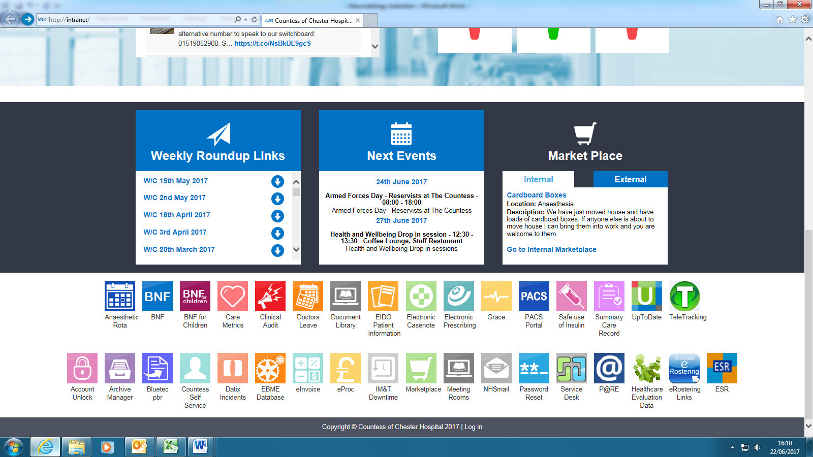

* **6 weeks notice is required for either annual or study leave requests**
* **Please inform Alison Stevens, team leader and Dr Nixon of any planned leave**

**Sick Leave**

* In the case of sickness, in the first instance juniors should inform the Rheumatology secretaries as soon as possible to allow them to cancel clinics
* Secondly, medical staffing to advise them of your absence

**Medical Students**

Medical students are encouraged to gain experience in our Rheumatology department. We like to have 1 student attend clinic at a time and they can arrange this by contacting the Rheumatology secretaries. The Thursday morning early arthritis clinic is recommended for students as it is a good opportunity to see inflammatory signs, however there are a number of different clinics available for learning opportunities.

**Guidelines**

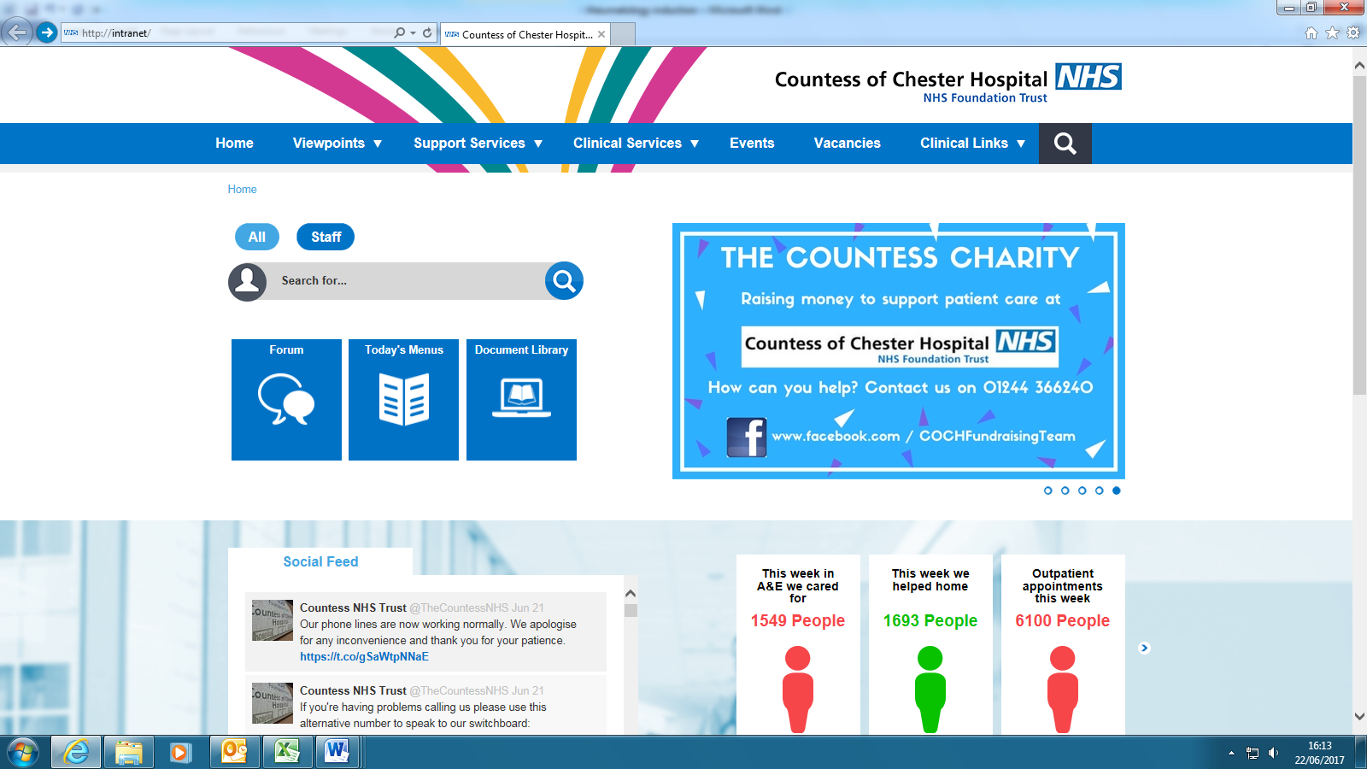An up to date list of guidelines and pathways for the Countess of Chester can be found via the homepage of the hospital intranet. Click on the **‘Document Library’** link. You can either then search for specific words or click ‘clinical specialities’ to see a list of guidelines divided by speciality.

**Useful Numbers**

|  |  |
| --- | --- |
| **Switch** | 0 |
| **Bleep** | ‘82’ |
| **Rheumatology nurses** | 4587 |
| **Rheumatology Pharmacist** | Bleep: 2447 |
| **Biochemistry** | 5651 |
| **Microbiology - results** | 6770 |
| **Medical Microbiology - advice** | 6773 |
| **Main radiology reception** | 5270 |
| **Inpatient X-ray enquiries** | 5278 |
| **CT control room** | 5756 |
| **Ultrasound** | 5274 |
| **Interventional radiology** | 6722 |

**Useful guidelines, letters and hand-outs**



 ************

Countess of Chester Joint injection policy.

# Background.

We are currently overwhelming our joint injection capacity which consists of adhoc Ultrasound guided injection lists and 1.5 per week rheumatology joint injection clinics. This is likely to further decrease with a relative reduction in registrar capacity. This is resulting in long waits for most injections. Therefore following an audit of the ultrasound and palpation guided joint injection clinics and following an MDT discussion we propose these guidelines for referring patients.

# Guidelines.

1. Patients requiring injection for active inflammation should be clearly identified and prioritised using tick box on referral form.
2. Patients with more than one actively inflamed joints should be considered where possible for an escalation in systemic therapy rather than joint injection
3. Ultrasound guided injections are limited in availability and therefore should be reserved in the main for:
   1. Diagnostic uncertainty which requires simultaneous US for diagnostic information
   2. Peri-tendinous injections
   3. Small joint injections only when there is evidence of very narrow joint space on Xray
4. All other joint injections can be referred for palpation guided injection
5. Mechanical shoulder disease, mechanical Achilles tendonitis, greater trochanter pain syndrome and epicondylitis should be referred for initial physio treatment prior to considering injection
6. Physio should be strongly considered for other mechanical joint pain prior to injection
7. Joint injection for symptomatic relief in osteoarthritis will not usually lie within the remit of the rheumatology department and should be used sparingly. We will embark on conversations with the Orthopaedic departments and the CCG to decide on the most appropriate venue for these injections.

**Intra-articular corticosteroid for knee osteoarthritis**

**Peter Jüni, Roman Hari, Anne WS Rutjes, Roland Fischer, Maria G Silletta, Stephan Reichenbach, Bruno R da Costa.** 22 October 2015.Editorial Group: [Cochrane Musculoskeletal Group](http://onlinelibrary.wiley.com/o/cochrane/clabout/articles/MUSKEL/frame.html)**.** DOI: 10.1002/14651858.CD005328.pub3

O**steoarthritis care and management.** NICE CG177. 2014. <https://www.nice.org.uk/guidance/CG177>

# Countess of Chester Virtual Biologics Clinic

## Principal: Final review of clinical decisions made by rheumatology team regarding biologic prescriptions:

Doesn’t remove autonomy from clinical team

Feedback to prescriber if alternative biologic to be considered

Streamline collection of data and generation of prescriptions

Meetings should be timely to avoid treatment delays

## Time and venue: Ellesmere Port Hospital 11-12am every Monday or Tuesday am.

## Core membership: Theresa Barnes, Hoda Temple, Emma Mulvey, Cath Brownsell, Penny Jones, Rebecca Houston, Helen Jeffrey.

## Invitees: Any member of the Rheumatology Team including but not limited to all consultants, all rheumatology specialist nurses, rheumatology trainees and the rheumatology management teams. Anyone else can be included by consent of the team and by invite only.

## Quoracy: To be considered quorate the meeting should include Penny Jones or qualified deputy, Theresa Barnes or Hoda Temple, Cath Brownsell or Emma Mulvey, either member of the core research team to include Theresa Barnes or Helen Jeffrey, Rebecca Houston(paperwork to be forwarded to Janice Lever in Rebecca Houston’s absence.

## Chair: Theresa Barnes

## Purpose of the meeting: To review all new biologics prescriptions including switches to ensure

1. Optimal delivery of the locally agreed pathways
2. Maximal recruitment to clinical trials
3. The most appropriate drug for an individual patient with an individual clinical background based on the latest available evidence.
4. Where no specific clinical indicators to start cheapest biologic
5. To ensure baseline screening completed within an acceptable timeframe
6. To promote timely entry of audit data.
7. To ensure timely generation of prescriptions
8. To ensure compliance with Hackett in checking of scripts
9. To fill in blueteq if this becomes mandatory

## Roles of the rheumatology team;

Referring clinician:

1. Collection of 1st DAS28, PsARC or BASDAI/VAS
2. To collect information regarding potential biologic contraindications
3. To ensure baseline data collected
   1. Quantiferon Gold
   2. Hep B, C and HIV
   3. IGs, RhF, and Anti CCP, ANA
4. To refer to the Rheumbio clinic for second assessment by rheumatology nurses or other member of the Rheumbio delivery team.

### Rheumbio team:

1. Ensure patient is eligible for biologic therapy (i.e. perform second score where appropriate)
2. Ensure no contraindications
3. Suggest preferred biologic option according to locally agreed pathway
4. Collect patient preference if any
5. Ensure patient is aware that decision to be reviewed by VBC for final decision
6. Perform CXR

### Penny Jones or deputy:

1. To ensure that all the relevant information including EVOVLED clinical notes are available at VBC.
2. To fill in the BAT database at the VBC
3. To populate the biologics prescription for the VBC

### Helen Jeffrey or deputy:

1. To ensure that all patients eligible for clinical trials are flagged to the VBC.

### Theresa Barnes or clinical member of VBC:

1. To ensure that locally agreed pathways are adhered to and to generate IFRs and other notification papers as required by locally agreed pathways.
2. To ensure that funding stream is secured and clearly record funding stream in notes.
3. To ensure that the most suitable biologic drug is given to the patient in line with the latest available evidence.
4. To ensure that the cheapest clinically appropriate drug is prescribed for the patient.
5. To ensure that the patient has no contraindications to biologics and that eligibility criteria are fulfilled.
6. To assist Penny Jones or deputy in filling in the BAT database as required.
7. To sign the biologics prescription and registration documents.

### Rebecca Houston or deputy:

1. To act as a member of the clinical team as above
2. To sign off the biologics prescriptions in line with Hackett mandated pharmacy check
3. To facilitate communication of the final prescription and registration documents to the Homecare provider or other appropriate provider. Collect information for pharmacy based database.



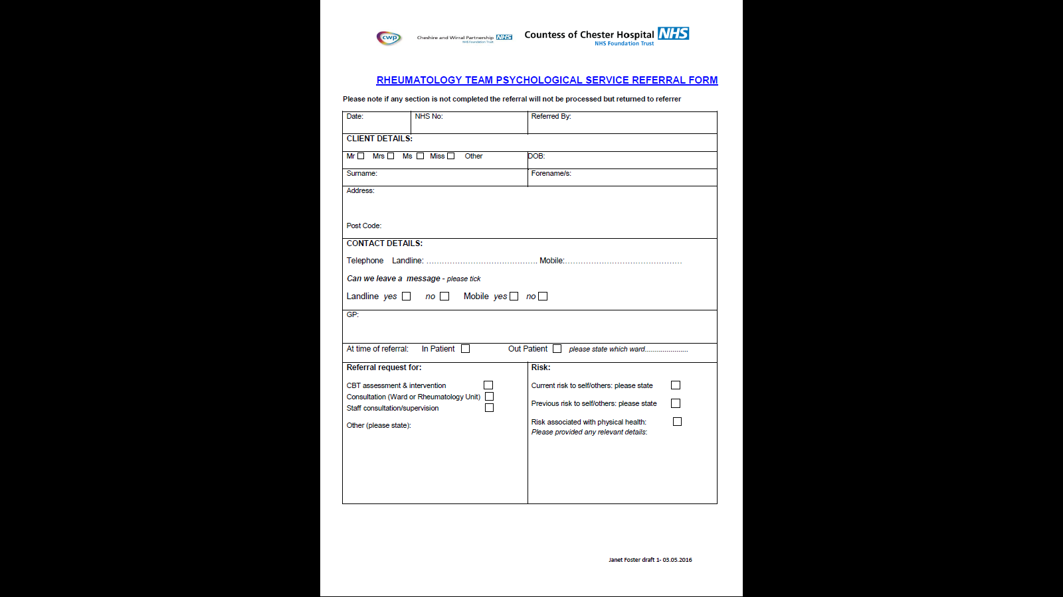

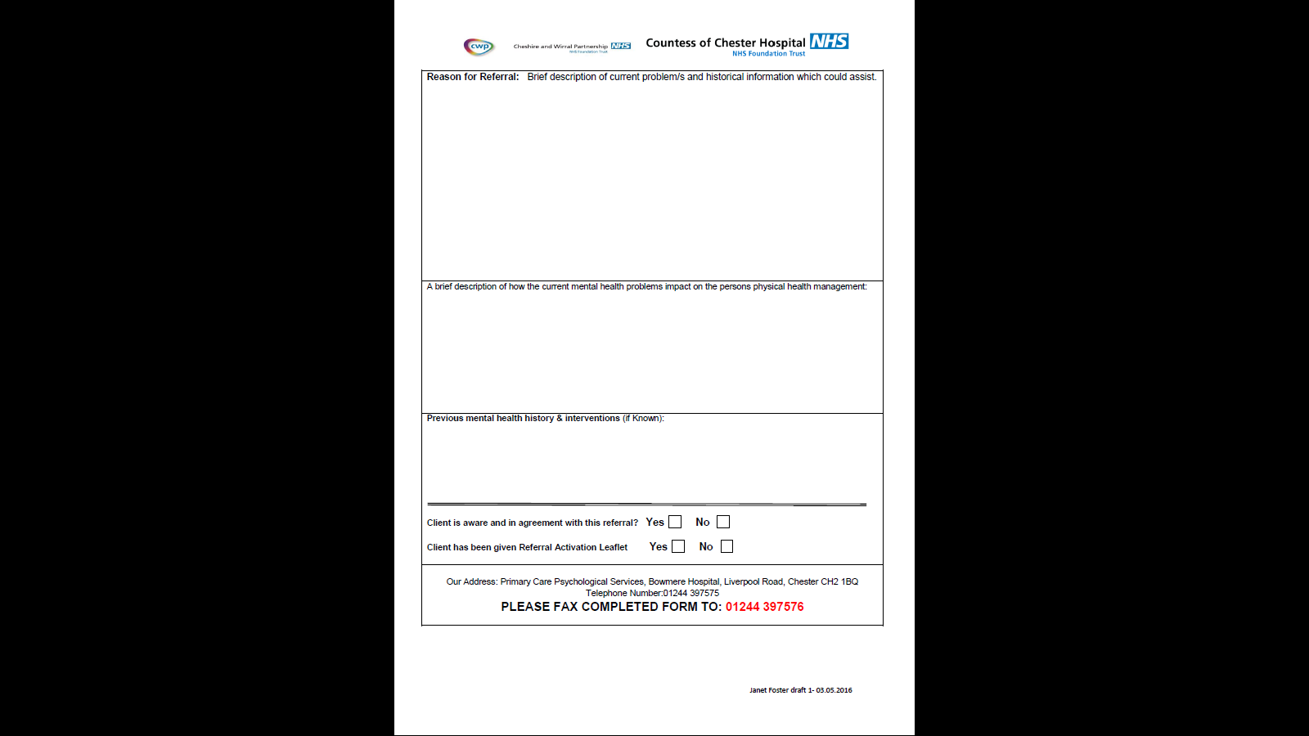

Other pathways / protocols

The vasculitis protocol and cyclophosphamide protocol are on the intranet also.

[http://doclib.xcoch.nhs.uk/Documents/Guidelines for the management of ANCA-Associated Vasculitis.docx](http://doclib.xcoch.nhs.uk/Documents/Guidelines%20for%20the%20management%20of%20ANCA-Associated%20Vasculitis.docx)

For stable patients who are able to self manage their condition adequately we have a Patient initiated clinic stream, the details of which are below:



We have agreed ideal patient pathways for follow up that we try to adhere to where possible:



